M I N D S P O R T
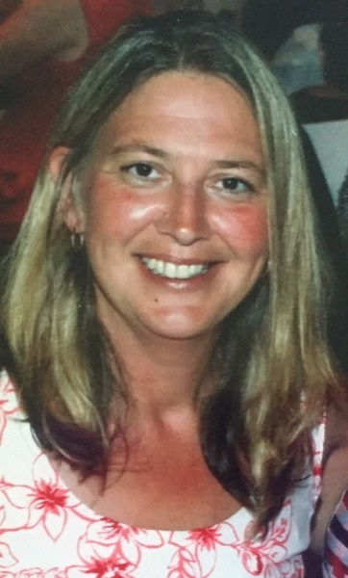
Meet Kate Davies, a sporty ambitious young woman, who suffered life changing arthritis at age 20.

Kate loved the challenges of competitive sport and the adrenalin rush it gave, but physically her arthritis was limiting. Not one to sit still nor miss an opportunity she channelled those energies into the sport of BRIDGE. Bridge is MIND SPORT. It is the ultimate team game, a strategist’s heaven, with all of sports highs and lows, attack and defence. It’s a 3D game; you play the opposition around the table and at the same time you play the person sitting in your seat around the room. What more do you need? For Kate, in 2019 it means international honours playing for New Zealand. And that could well be your opportunity too.

In the words of Bill Gates “Bridge is a game you can play at any age. If you take it up young, you will have fun playing it for the rest of your life. A lot of games don’t have that depth. This one does.”

If you are up for a challenge and find yourself being limited by an injury, ageing joints or some other physical illness then make the most of that down time and learn a new skill that will last a lifetime. Bridge – sport for the Mind.

Your local Bridge Club welcomes you; lessons run regularly.

Contact …x... on ..phone number… or …email….

