**PLAYER COMMENTS**

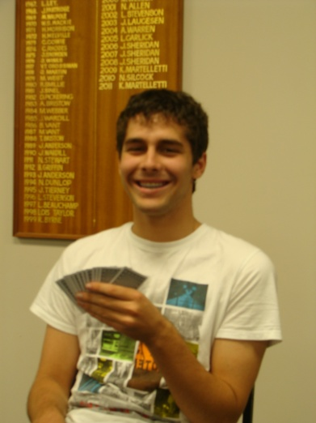

“*Bridge is a great game for people of all ages. I enjoy the competitive side of the game . It is also lots of fun trying out new ideas ”*

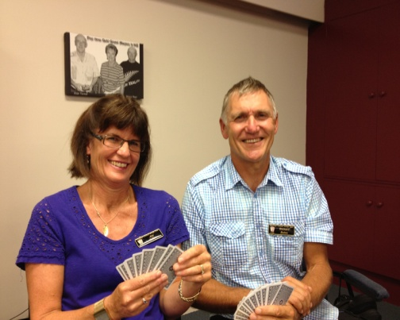

“*We enjoy playing Bridge together. We can practice together at home and further hone our skills at the Club”*

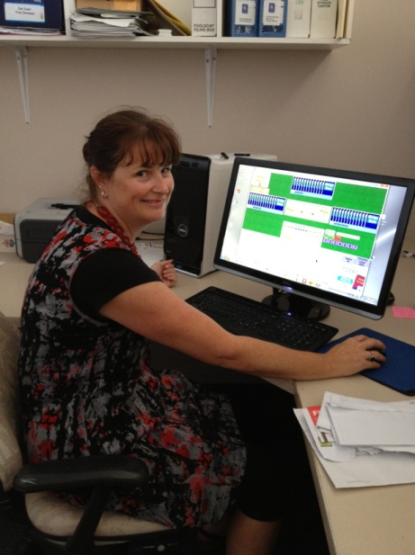

“*I enjoy playing Bridge at the Club. It is also fun playing online with people from all over the world ”*

**FAMOUS BRIDGE PLAYERS**



***Bill Gates***– Billionaire businessman and philanthropist. Gates reportedly got addicted to Bridge through Warren Buffett (American Business Magnate) and the two now play regularly online and in tournaments. Gates has a reputation as an enthusiastic learner, studying and playing with professionals to refine his game.

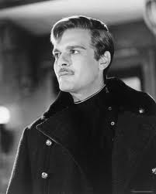♣ ♦ ♥ ♠

***Omar Sharif* -** Charismatic star of "Lawrence of Arabia" and "Doctor Zhivago", Omar Sharif has also enjoyed a long career as an expert bridge player touring the world and writing numerous columns and books. [](http://www.google.co.nz/imgres?imgurl=http://www.celebritiesfans.com/pictures/omar_sharif.jpg&imgrefurl=http://www.celebritiesfans.com/addresses/actors/omar-sharif&h=450&w=360&sz=26&tbnid=8ehCjJ4iwLns_M:&tbnh=101&tbnw=81&prev=/search?q=Omar+Sharif&tbm=isch&tbo=u&zoom=1&q=Omar+Sharif&docid=sOPmEaRCiqZ5FM&sa=X&ei=UlM9T-CrOs70mAW4quC8Bw&ved=0CEUQ9QEwAg&dur=)

♣ ♦ ♥ ♠

***Martina Navaratilova*** – Tennis legend and 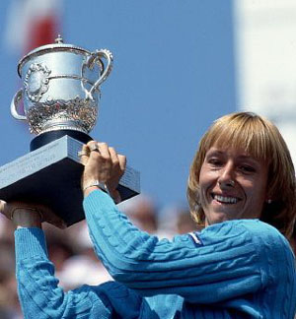winner of 59 Grand Slam titles. On the topic of bridge, she has been quoted as saying “No matter where I go, I can always make new friends at the bridge table. Bridge teaches logic, reasoning, quick thinking, patience, concentration and partnership skills”

|  |
| --- |
| **learn to play Bridge**  **…**  **the best card game in the world** |

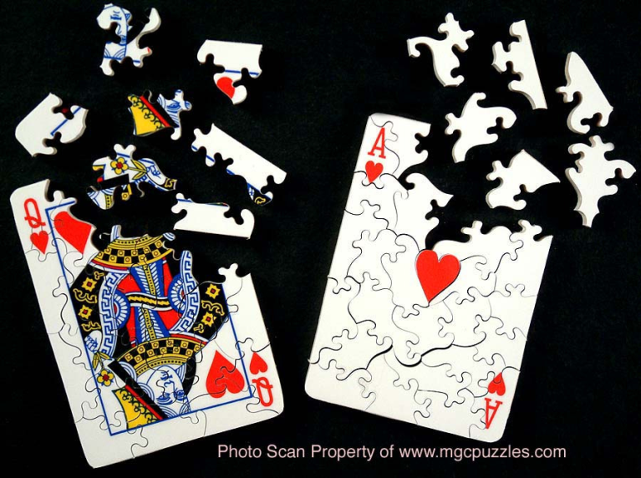

Is it a puzzle or is it a game of cards?

**WHAT IS THIS GAME CALLED BRIDGE?**

Congue nihil imperdiet doming id quod mazim placerat facer minim veni am ut wisi enim ad minimeniam, quis erat nostr uexe

rci tation ullamcorper nostru exerci tation ullam corper et iusto odio dig nissim qui blandit praesent lupta. Tummer delenit

augue duis dolore te feugait nulla facilisi. Con erattis sectetuer adip iscing elit, sed erat diam nonummy nibh magna erat.

Bridge is a game a little like Five Hundred, and is derived from a card game called Whist. It involves two partnerships playing against each other to win tricks and gain points.

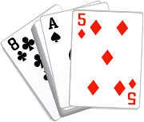

There are two parts to each hand of Bridge – the bidding and the play. During the bidding each pair decides if they would like to have a trump suit or if they would to play the hand without a trump suit (no-trumps). There are four suits:

♣ Clubs ♦ Diamonds ♥ Hearts ♠ Spades

Once a pair has nominated a contract, they will try to take the required number of tricks. The other side, known as the defenders, will attempt to defeat the contract.

Points are either given to the pair that chose a suit as trumps, or no trumps if they make the contract. If the defenders defeat the contract, the defenders will score the points.

The language of Bridge is rich in colloquialisms, including terms such as The Beer Card, Duck, Finesse, Hook, Kibitzer, Sacrifice, Squeeze and Stiff.

At the end of each session of Bridge, your scores are compared with the scores of the other players. The luck of being dealt 'good' hands is therefore removed. Other players will have the same cards as you - it is therefore a comparison of how well you did with the cards that matters.

**HOW CAN I GET INVOLVED?**

The Tauranga Bridge Club is the largest club in the Tauranga area with almost 400 members. Bridge is played every day at the club as follows:

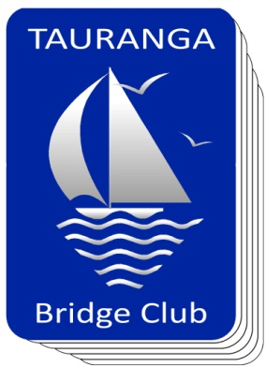

Monday:        7.30pm

Tuesday:        1.00pm

Wednesday:         7.15pm

Thursday: 1.00pm (Social)

            7.30pm

Friday:         1.00pm

Sessions are usually about 3 hours long. If you do not have a partner, one can be arranged for you if you ring the club (576 5022) to let us know that you are coming. Alternatively you can check our website ([www.taurangabridge.co.nz](http://www.taurangabridge.co.nz)) for the name of the partnership steward who assists with finding partners for the particular session that you want to play.

If you have been playing Bridge socially and would like to play in a Club, we have supervised sessions as outlined above.

The Social Bridge session and Wednesday session in particular will assist to ease you into the world of club Bridge. We cater to all levels from the beginner to the expert.

♣ ♦ ♥ ♠

**BRIDGE LESSONS**

While Bridge can be challenging to play at higher levels, it is easy to learn the basics. You can come to lessons on your own, or with a partner.

If you would like to learn Bridge go to our website [www.taurangabridge.co.nz](http://www.taurangabridge.co.nz) and register, or telephone the office (576 5022) to make the necessary arrangements.

Lessons are run on Wednesday evenings starting at 7.15pm and start on 6 March 2013. The lessons will run for 13 weeks and include course material and plenty of practice opportunities.

Lessons cost $70.00 and include membership to the Tauranga Bridge Club for 2013.

**MEET NEW FRIENDS**

Bridge lets you sit down with people that you have never met and have a wonderful time. You can play Bridge on cruise ships, in tourist resorts, on organised tours of other lands, on holiday here or overseas or even on a business trip. Worldwide Bridge players love to see new people and talk about where you come from.

Bridge can also be played online in both competitive and social situations. There are many websites available for all abilities. The language of Bridge is universal and overcomes all language barriers.