28th HAWKE’S BAY  BRIDGE CONGRESS | 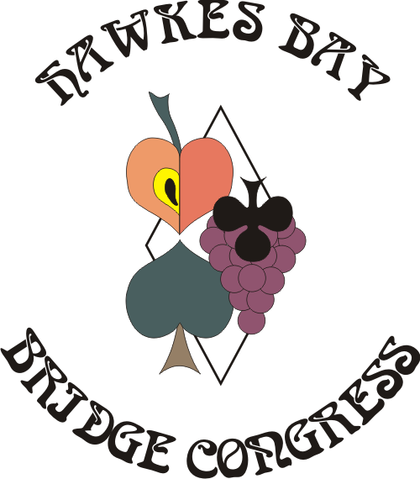 | Queen’s Birthday Weekend  4th June – 8th June, 2021
HASTINGS SPORTS CENTRE – 503 Railway Road, Hastings

Programme

Friday 4 June REGISTRATION OPENS 6.00pm
Walk in Pairs – 7:30 pm (1 session)

Saturday 5 June 15A Match Point Swiss Pairs – Start at 9:30am (3 sessions)
Sponsored by George Masters Motors

5B Intermediate Pairs* – Start at 9:30am (2 sessions)

3B Junior Pairs* - Start at 9:30am (2 sessions)
Sponsored by Kinnect Group *Separate Events dependent on sufficient entries*

Sunday 6 June John Eldridge 15A Teams Qualifying – Start at 9:30am (3 sessions)
Sponsored by O’Briens Plumbing Supplies

5B Intermediate Teams* – Start at 9:30am (3 sessions)

3B Junior Teams* - Start at 9:30am (3 sessions)
Sponsored by Kinnect Group

Monday 7 June 10A Swiss Pairs – Start at 9:30am (2 sessions)
Sponsored by Aramex
John Eldridge Teams Final – Start at 9:30am (5 matches)
Inter-Club Novice Teams – 10:00am (6 matches)

Tuesday 8 June 5A Multi-Grade Pairs – Start at 9:30am (2 sessions)
Sponsored by O’Briens Plumbing Supplies

Presentation of Prizes at conclusion of each Event

Entry forms attached, in your club rooms or REGISTRATION FEES (per person)

players may enter via our website Full Congress Entry- 4 days OPEN $200 or INT / JUN $120

www.hawkesbaycongress.nz Part Congress Entry- 3 days OPEN $160 or INT / JUN $90

Closing date 28 May, 2021 Single Event Entry available: (per person)

All enquiries to: Judith Boxall Walk In $10 Match Point Swiss Pairs $60
17 Alderney Close, Taradale 4112 Intermediate & Junior Pairs $30
Open Teams $120 (includes Monday event)
Email: bjandjaboxall@xtra.co.nz Intermediate & Junior Teams $45 Novice Teams No charge
Swiss Pairs $55 Multi-Grade Pairs $40

Payment required with entry Lunch NOT Included – there will be an option to order SUBWAY

Please Direct Credit to: Westpac Account 03 1517 0009790 00
and reference with Name and Computer Number
NOTE: as most banks are not accepting cheques NO CHEQUES PLEASE

PLEASE SUPPORT OUR SPONSORS
