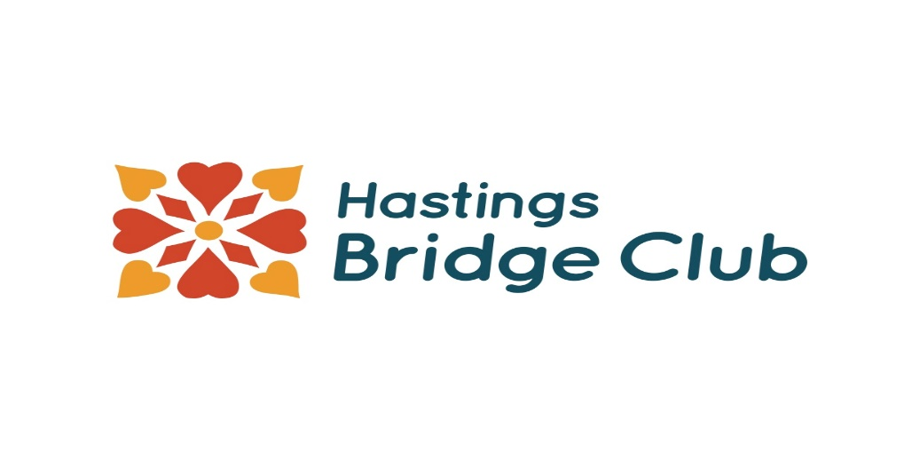

HAWKES BAY CHRISTMAS CHEER
(5A SWISS PAIRS)
Sponsored by
George Masters Motors

Date: 27th November 2021

Venue: 911 Railway Road, Hastings

Entry Fee: $30.00. Generous prizes for all grades

Start Time: 9.30 am

Catering: BYO lunch.

Closing Date: Wednesday 24th November 2021

Entries: www.nzbridge.co.nz/events
Mairi Fitzsimons - Tournament Secretary Ph 021 509957

This event will only run subject to covid19 regulations. Only people who are fully vaccinated can play. Please bring your vaccination certificate with you so that we can check it off.

